Lab 6: Actor-based Distribution

Dawid Skraba 19433692

Task1:

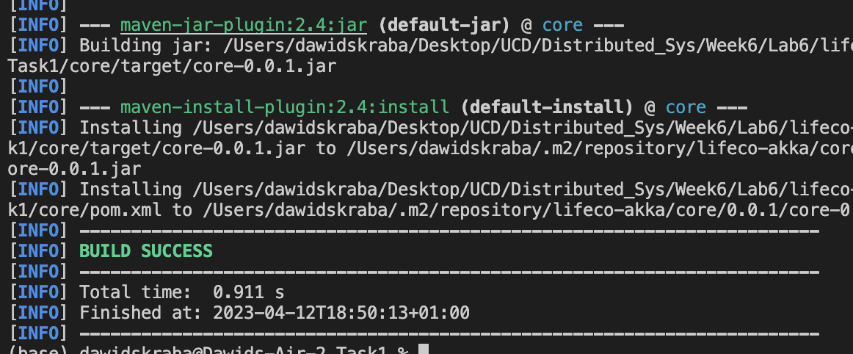

Task2:

Task3:

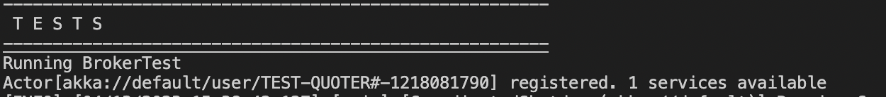

Task4:

Task5:

